**Homework #9 Assignment**

GK Posted March 2023

**Instructions:**

Your answers should be *direct and explained*. Show your calculations, formulas, logic you follow etc. Explanations do not have to be verbose; they should be just enough for the instructor and/or TA to understand what you are doing. 80% of the grade goes to the explanations and logic you follow and 20% goes to the result. *Correct result with no explanations gets zero points*.

Please respond with your own words and own understanding. Copying the answers without understanding them, defeats the purpose of this homework -- it violates the code of ethics and the integrity of the course.

* *If you are* ***suspected*** *of copying any part of your answers either from a classmate or a web site (without a reference link), you get a zero to the entire homework.*
* *If it is* ***proven*** *that you have copied or plagiarized, you will be reported to your advisor, your sponsor, and the School; serious consequences to your academic record and/or your student status should follow.*
* *This is applicable to both the giving student and the recipient student*.

For the problems/exercises, it is expected to use a spreadsheet (Excel) and/or your own drawing tool (PowerPoint, Visio, Drawsoft, etc) or make a neat drawing by hand. ***You must embed*** these assets into your WORD file with no external references, specifically for Excel. Unless the TA or I click-and-open the object to see your calculations, you will be missing points. *If you do not know how to do so, ask your colleagues, post the question to the Discussion Homework Area, ask our TA and/or ask me.*

Please use font Arial or Calibri of 9pts or 10pts.

DO NOT REMOVE THIS PAGE FROM YOUR SUBMISSION. Also, answer the questions below:

*How long did it take you to complete this homework? _______5________ hours*

*How many hours did you work on your project this week? ____2_______ hours*

Table of Contents

1. AOA, 15pts 2

2. Z(p%), 15pts 2

3. NutriStar: 20pts 3

4. NETW2b: 20pts 5

5. PATH2: 20 pts 6

6. JOINT: 10pts 6

## AOA, 15pts

You are given the following WBS

|  |  |  |
| --- | --- | --- |
| Activity | Duration | Predecessor |
| A | 1 |  |
| B | 2 |  |
| C | 3 |  |
| D | 4 | A |
| E | 5 | B |
| F | 6 | B |
| G | 6 | C |
| H | 6 | D, E |
| I | 2 | G |
| J | 3 | H, F, I |

**Create the AOA**

*Requirements:*

*(1) your graph to be very readable, either using a tool or “by hand” with clear and unambiguous lines (no smudges please!) (-5 points otherwise)*

*(2) You must provide explanations for every dummy task you add. (-5 points otherwise)*

*Hint: Follow the steps presented in Class#9. First create an AON meeting the WBS dependencies. Second examine parallel paths and introduce dummy tasks for the shorter paths. Finally number the nodes.*

**Answer:**

AON

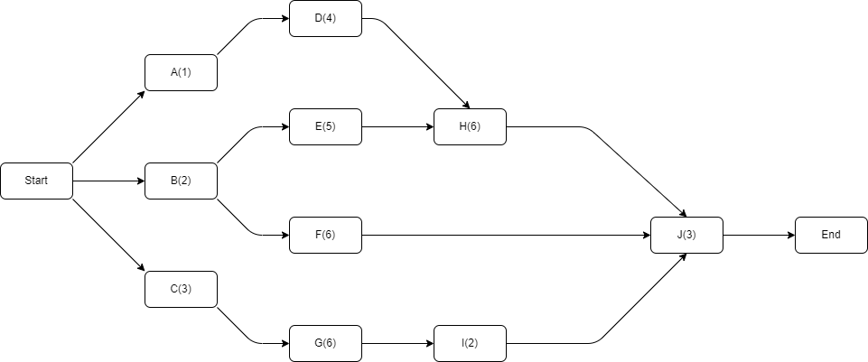

AOA

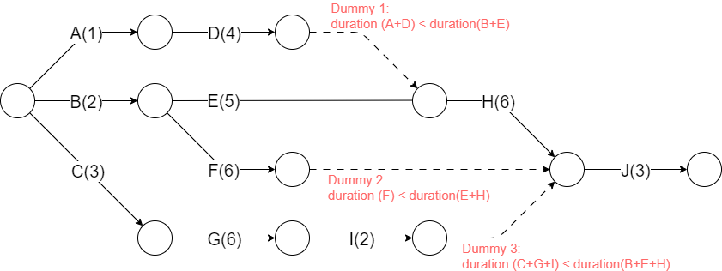

## Z(p%), 15pts

1. (1pt) What is Z(p) when p = 90%?
2. (1pt) What is Z(p) when p =10%?
3. (1pt) What is p(Z) when Z= 2?
4. (1pt) What is p(Z) when Z= -2?
5. (6pts) Assume that if a project delivery is extended by 12-days, the probability to completion increases to 90%. What is the probability to complete the project 6-days earlier?
6. (6pts) Assume that if project is accelerated by 7-days, the chances are 10% to be completed. How much more time beyond the normal course would it take for the project to be completed at 95% probability?

*Your answers must include the logic or formulas you have used. In addition, answers must be expressed in no more than 3-significant digits. (-5 points otherwise)*

**Answer:**

5. the probability is 26.1%.
6. 9 days.

## NutriStar: 20pts

First, read the business case from the textbook “NutriStar Energy” – located immediately after the Bibliography of Chapter 8.

Second, review the slides shown in Class regarding NutriStar Energy. The slides include very important hints which will help you answer the questions below.

1. (5 pts) Based on the description of the business case, create the WBS Table with dependencies. For this step ignore the duration of tasks – just focus on dependencies. Use a spreadsheet to do this.  
   Expand your WBS using Table A given in the slides and add the duration of each task.   
   ***>>Copy the spreadsheet in this homework. Your WBS must be shown in this WORD file without clicking any links. No credit otherwise.***
2. (5 pts) Create the Network Diagram using the previous WBS. Include dependencies and durations. Identify the critical path. You must include the network diagram in this WORD file. No credit otherwise.
3. (5 pts) Compute the TE of each task. Use the beta distribution as discussed in the class (i.e. 1:4:1 average of a, m, b). Add the TE in your spreadsheet.

Identify the Critical Path(s) in your spreadsheet

Compute the standard deviation ***of each task*** along the Critical Path.   
***>>Copy now the updated version of the spreadsheet in this file. No attachments needed – just a copy of the updated table. No credit otherwise.***

1. (3pt) Compute the standard deviation ***of the critical path. Show your calculation in this file. No credit if calculation is not shown.***
2. (2pt) What is the probability that the team finishes the project 4-months earlier? ***Show your calculation in this file. No credit if calculation is not shown.***
3. (2pt) Assume that the team is given 4-more months to complete the project. What are the odds now (what is the probability of completion 4-months later).  
   *Hint: Utilize the symmetry of (-Z, Z) 🡪 (p%, 1-p%)*
4. (3pt) Your boss says: “I want to commit to the stockholders of the company that the project is likely to be completed (i.e. >90%). What would be the duration of the project in this case?

*Finally, in addition of* ***copying*** *sections of Excel spreadsheet, you must also* ***embed*** *it at the end of this question. No credit on this problem at all, if your Excel file is missing or not embedded correctly*

**Answer**

|  |  |  |  |  |  |
| --- | --- | --- | --- | --- | --- |
| ID | Activity | Duration(TE) | Standard Deviation | Critical Path | Predecessor |
| 1 | definition of the plan |  |  |  |  |
| 1.A | concept development | 12.5 | 3.5 | 1 | - |
| 1.B | defining the project scope | 3.5 | 1.8 | 1 | 1.A |
| 1.C | developing a broad schedule of activities | 0.5 | 0.1 |  | 1.A |
| 1.D | developing detailed cost estimates | 0.3 | 0.1 |  | 1.A |
| 1.E | developing a plan for staffing | 0.3 | 0.1 |  | 1.A |
| 2 | design and construction |  |  |  |  |
| 2.A | detailed engineering | 3.3 | 0.7 |  | 1 |
| 2.B | mobilization of the construction employees | 13.3 | 2.7 | 1 | 1 |
| 2.C | procurement of production equipment | 2.1 | 0.6 | 0 | 2.A, 2.B |
| 2.D | construction of the facility | 4.2 | 1.8 | 1 | 2.A, 2.B |
| 3 | start-up and turnover |  |  |  |  |
| 3.A | pre-start-up inspection of the facility | 0.5 | 0.1 | 1 | 2.C, 2.D |
| 3.B | recruiting and training the workforce | 0.5 | 0.1 |  | 3.A |
| 3.C | solving start-up problems | 1.0 | 0.3 | 1 | 3.A |
| 3.D | determining optimal operating parameters (called centerlining) | 1.3 | 0.7 | 1 | 3.B, 3.C |

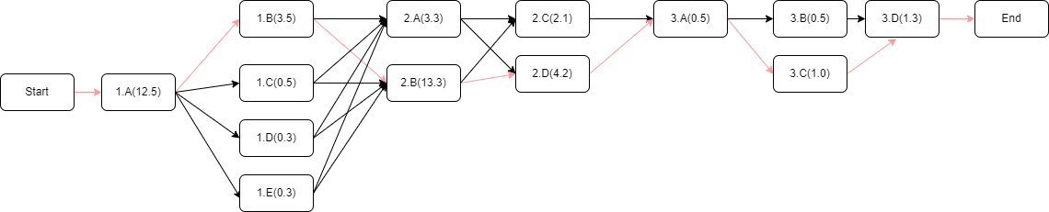

d

e   
f

g

43 months.

## NETW2b: 20pts

Refer to NETW2 of Homework#8

Your team assessed the risks of each task, with the following conclusions

* task D was estimated 5-days +/-2days
* task F was estimated optimistically as 5-days and conservatively 13-days
* task H was estimated optimistically as 2-days and conservatively 4-days

All other tasks did not have much risk and were assessed as before.

1. (6pts) What would be the duration of the project with 50% probability?
2. (7pts) If the project is to be completed with 95% probability, how many extra days would it take?
3. (7pts) Assume that your boss is asking you to finish a day earlier. What are your chances?

*Hint: Must explain each of your answers and show the calculations and formulas you apply. No credit to the respective question. For this problem, you earn 50% if your logic is correct; if your logic is correct you get an additional 50% if your answer correct – i.e. no credit if the logic is not correct.*

**Answer:**



## PATH2: 20 pts

You are given a project with the following tasks and durations – tasks dependencies are not given:

|  |  |
| --- | --- |
| **Task** | **m** |
| A | 5 |
| B | 8 |
| C | 10 |
| D | 5 |
| E | 8 |
| F | 7 |
| G | 9 |
| H | 3 |

After you did the AON Network Diagram, you discovered that you have two critical paths.

* First critical path is **C-D-F**
* Second critical path is **A-D-E-H**

Your team was certain about most of the tasks, except tasks B, G and H

* For B, the estimate of 8-days could be +/-4 days
* For G, the optimistic estimate was 6-days and the pessimistic was 16 days
* For H, the optimistic estimate was 2-days and the pessimistic was 10 days

Please answer the following questions:

1. (4 pnts) What is the estimated time to completion of the project? *Explain how you derived this.*
2. (6 pnts) What is the standard deviation of the first critical path? *Show your calculations*
3. (2 pnts) What is the standard deviation of the second critical path? *Show your calculations*
4. (6 pnts) Consider the first critical path, what is the probability of completion one day earlier?
5. (2 pnts) Consider the second critical path, what is the probability of completion two days earlier?

*Embed your Excel spreadsheet. Then, write your responses in the WORD file, referring to the specific CELL and calculation method or formula you used. Zero points if Excel is not embedded or your CELL formula is not clearly shown.*

**Answers:**

1. Only H of {B, G, H} is on critical path

4. zero, every task has certain duration.

## JOINT: 10pts

*(Even this problem refers to PATH2, it is totally independent. Even if you have not solved correctly PATH2, you should be able to solve this problem.)*

Consider the problem PATH2. You had two critical paths. Of course, the two paths had to have the same duration, otherwise one of them would not have been critical.

Let’s say that you computed the probability p1% to accelerate PATH-1 by 1-day and you found 25%.

You did the same calculation for PATH-2; to accelerate by 1-day and you found p2% be 35%.

a. (5pts) What is the probability of completing ***the project*** one day earlier? Explain why – no credit if incorrect or missing explanation.

b. (5pts) Under what assumptions your previous answer is correct?

**Hint:**

* *The Study Guide helps with specific sections of the textbook.*
* *Consider the resources needed for each path.*

**Answer:**

a.   
Because the probability of multiple paths with the same start and end point are the product of the individual probabilities

b. the probabilities of 2 critical paths are mutually independent